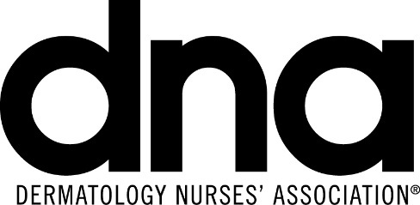
Dermatology Nurses’ Association
DNA Annual Convention
February 28 – March 3, 2017
Orlando, FL

CONVENTION PROGRAM BOOK ADVERTISING SHEET

As an additional service to our exhibitors, we are offering advertising space in our program book.

Trim Size 6” x 9” Bleed Size 6 ¼” x 9 ¼” Keep live matter ½” from both trim and gutter.

Exhibitor Costs
One Page/Four Color 5" x 8" $ 3,000 2nd Full Page Color 5" x 8" $2,500
No Agency or Cash Discount extended

☐ Yes, we want to reserve Advertising Space in the Official Convention Program

Full Page/Four Color ☐ 2nd Full Page Color ☐

Closing date for reserving Advertising Space by January 16, 2017.

Please forward all ad materials via email (high resolution pdf files) to: heidi.perret@ajj.com no later than February 1, 2017:

DNA PROGRAM BOOK
c/o Anthony J. Jannetti, Inc.
East Holly Avenue Box 56, Pitman, NJ 08071-0056
Telephone: 856-256-2375, Fax: 856-589-7463, email: heidi.perret@ajj.com

Check should be made payable to DNA (DNA Tax ID: 22-2485816)

Company Name:

Address:

City: State: Zip Code:

Telephone: / / email:

Contact Name:
Full Payment by Credit Card

Visa MasterCard AMEX

Name on Credit Card:
Credit Card Number:
Expiration Date: / Security Code: Charge Amount:
Credit Billing Address: street #: Zip code:
Signature:

